# Lab_06_02 -- Chapter 06

## Lab Description:

In this lab, you will walk through a few tutorials. You will practice using the Math class, the Wrapper classes, and formatting output in Java.

## Lab Requirements:

1. Read and do the tutorial for the Math class
   1. <https://docs.oracle.com/javase/tutorial/java/data/beyondmath.html>
   2. Create the BasicMathDemo.java and the ExponentialDemo.java classes, as shown in the tutorial. Don’t worry about the trig section.
   3. In BasicMathDemo.java, include a loop that outputs 10 random integers, ranging between 1 and 100 inclusive
   4. In ExponentialDemo.java, calculate the future value of $1000 invested for 10 years at 5.0%. Assume interest is compounded quarterly.
      1. 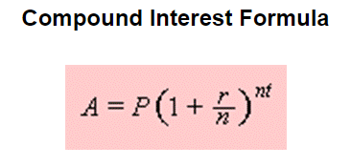
      2. 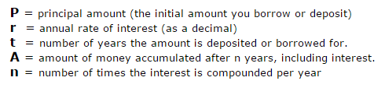
      3. Refer to this [article](https://qrc.depaul.edu/StudyGuide2009/Notes/Savings%20Accounts/Compound%20Interest.htm) if you need a refresher on compounding interest
2. Read and do the tutorial for the Wrapper classes
   1. <http://www.w3resource.com/java-tutorial/java-wrapper-classes.php>
   2. Create the WrapperDemo.java and ExponentialDemo.java classes, as shown in the tutorial.
   3. In WrapperDemo.java, as a last step output the min and max values for Integers
3. Read and do the tutorial for formatting numeric print output
   1. <https://docs.oracle.com/javase/tutorial/java/data/numberformat.html>
   2. Create the TestFormat.java class, as shown in the tutorial.
      1. Note, the DecimalFormatDemo.java tutorial is optional.
4. Use Java formatting conventions
5. Use comments where appropriate
6. Submit your source code to Blackboard
   1. You should have the following classes at the end of this assignment:
      1. BasicMathDemo.java
      2. ExponentialDemo.java
      3. WrapperDemo.java
      4. ValueOfDemo.java
      5. TestFormat.java
   2. Remember, your submitted source code must compile or a zero will be given